**LABSHEET 2: ASSEMBLY LANGUAGE PROGRAMMING OF**

**8085 MICROPROCESSORS**

**__________________________________________________________________________**

**Name: Aadithyan Raju Roll Number: AM.EN.U4CSE21301**

**___________________________________________________________________________**

1. **ONE’S COMPLEMENT OF AN 8-BIT NUMBER**

LDA 5100H ; Load Address Of Number In H-L Register Pair (Lower byte data).

CMA ; Complement Accumulator

STA 5101H ; Store The Result

HLT ; Terminate Program

|  |  |  |  |
| --- | --- | --- | --- |
| **INPUT** | | **OUTPUT** | |
| Memory location | Data | Memory location | Data |
| 5100H | 0 | 5101H | 255 |
| 5100H | 254 | 5101H | 1 |

1. **2’S COMPLEMENT OF AN 8-BIT NUMBER**

LDA 5100H ; Load Address Of Number In H-L Register Pair (Lower byte data).

CMA ; Complement Accumulator

INR A ; Increment

STA 5101H ; Store The Result

HLT ; Terminate Program

|  |  |  |  |
| --- | --- | --- | --- |
| **INPUT** | | **OUTPUT** | |
| Memory location | Data | Memory location | Data |
| 5100H | 0 | 5101H | 0 |
| 5100H | 254 | 5101H | 2 |

1. Show the output in 8085 simulator for the following programs. Attach the screenshot of final status of PC and relevant registers.
2. **Copy 10 numbers stored from the location 2050H to the new location 2070H**

START: LXI H, 2050H

LXI D, 2070H

MVI B, 0AH

NEXT: MOV A, M

STAX D

INX H

INX D

DCR B

JNZ NEXT

HLT

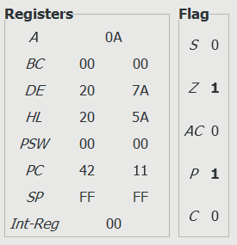

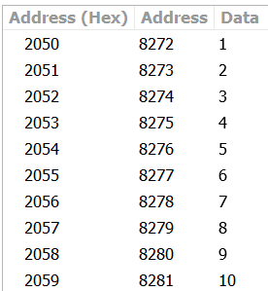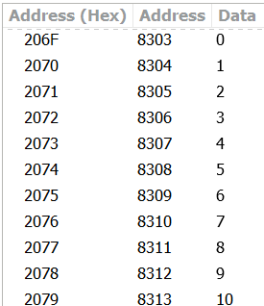

1. **8-bit Addition without carry**

;Addition of 2 numbers 15H and 10H

LDA 7000H

MOV B,A

LDA 7001H

ADD B

STA 7002H

HLT

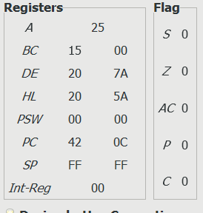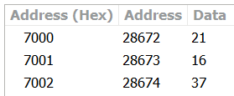

1. **8-bit Addition with carry**

;Addition of 2 numbers 250 and 30

MVI C,00H

LDA 7000H

MOV B,A

LDA 7001H

ADD B

JNC ahead

INR C

ahead: STA 7002H

MOV A,C

STA 7003H

HLT

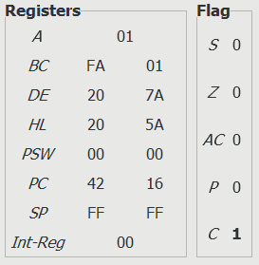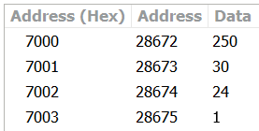

1. **8-bit Subtraction**

;Subtraction of 2 numbers 40H and 15H

LDA 3000H

MOV B,A

LDA 3001H

MOV C,A

MOV A,B

SUB C

STA 3002H

HLT

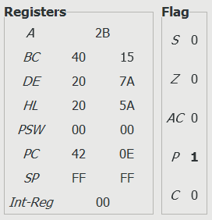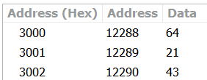

1. **8-bit Multiplication**

;Multiplying 2 numbers 12H and 03H

MVI A,12H

MOV B,A

MVI C,03H

MVI A,00H

Label1: ADD B

DCR C

JNZ Label1

STA 2001H

HLT

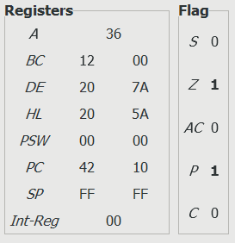

1. **8-bit Division**

;Division of 2 numbers : Dividend -> 4AH & Divisor -> 08H

LDA 2050H ; Load Divisor in Accumulator

MOV B,A ; Copy Divisor to Register B

LDA 2051H ; Load Dividend in Accumulator

MVI C, 00H ; Initialize register C for Quotient

Next: CMP B ; Compare the no. in B with the no. in Accumulator

JC Loop ; Jump if B>A to Loop

INR C ; Increment Register C (Quotient)

SUB B ; Subtract B from A

JMP Next ; Repeat the above steps till A becomes smaller than B

Loop: STA 2052H ; Store the remainder at memory address 2052

MOV A,C ; Move the contents of C to Accumulator

STA 2053H ; Store the Quotient at memory address 2053

HLT ; HLT

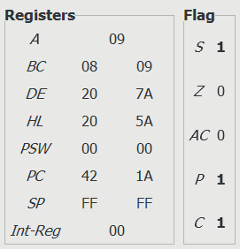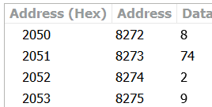

1. **16-bit Addition**

;Addition of 2 numbers 1020H & 2040H

LHLD 8501H ; Get first 16-bit number in HL

XCHG ; Save first 16-bit number in DE

LHLD 8503H ; Get second 16-bit number in HL

MOV A,E ; Get lower byte of the first number

ADD L ; Add lower byte of the second number

MOV L,A ; Store the result in L register

MOV A,D ; Get higher byte of the first number

ADD H ; Add higher byte of second number with borrow

MOV H,A ; Store the result in H register

SHLD 8505H ; Store l6-bit result in memory locations

HLT ; Terminate program

1. **16-bit Subtraction**

;Subtraction of 2 numbers 2040H & 1020H

LHLD 8501H ; Get first 16-bit number in HL

XCHG ; Save first 16-bit number in DE

LHLD 8503H ; Get second 16-bit number in HL

MOV A,E ; Get lower byte of the first number

SUB L ; Subtract lower byte of the second number

MOV L,A ; Store the result in L register

MOV A,D ; Get higher byte of the first number

SBB H ; Subtract higher byte of second number with borrow

MOV H,A ; Store the result in H register

SHLD 8505H ; Store l6-bit result in memory locations

HLT ; Terminate program

1. Write an assembly program in mnemonic code for 8085 processor to calculate

(A+B)-C where the value of

* + - A stored the value 34H at address 2300H
    - B stored the value 47H at address 2301H
    - C stored the value ABH at address 2302H

1. Write an ALP (Assembly Level Language) to add 10 numbers stored in the consecutive memory locations starting from 2000H. Write the code using conditional jump instruction. Store the final result in 200AH.